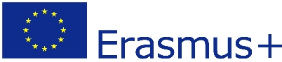
Maths Paths in Europe - Lesson Plan

Category: Maths in the kitchen
Year Group : year 1 (6 – 7 years olds)

Learning Objective:
- Using a scale to measure flower, sugar . . .
- Using words for weighing : more – less – exactly 100 grams . . .
- Following instructions to use a scale, to make the dough, to shape the cookies.
- Inventing different shapes for the cookies : round – square . . .
- Enjoying the cookiemathslesson.
Success Criteria:
- I can use a scale to weigh flour or sugar
- I can follow instructions to make cookies
- I can shape the cookies into round or rectangular forms

Lesson Description (including context) :

At the introduction of the lesson we talk about cookies, what kind of cookies we like, what they are made of, who makes them . . . Then the teaches announces ‘We are going to make our own cookies today!’

Resources:

- ingredients
- scale, bowl, aprons, oven

