

Maths Paths in Europe - Lesson Plan

Category: maths in the street
Year Group: class 6

Learning Objective:
Using maths in the street, showing to the children how maths is important in real life, measuring the distances, looking for numbers in the street, counting, dividing, changing units, looking at the prices
Success Criteria:

- Revising numbers in English, using adding, dividing and mulitipling

Lesson Description (including context) :
Children take necessary equipment to use it during the trip. They look for the numbers in the street and how are they used. They maeasure lines, pavements. They write correct equations. They calculate the numbers.

Resources:
Exercises,
Paper, pencil

Differentiation:
The students are divided into groups. They have different task according to their abilities.

Introduction:

Teacher revises vocabulary from the previous lesson connected with numbers and school things.

Main Lesson
Children are going outside to look the numbers in the street. They measure the pavement. They calculate the squares and circuits. They look for numbers on the houses, the post signs, streets numbers, the prices etc.

Plenary

Photographs

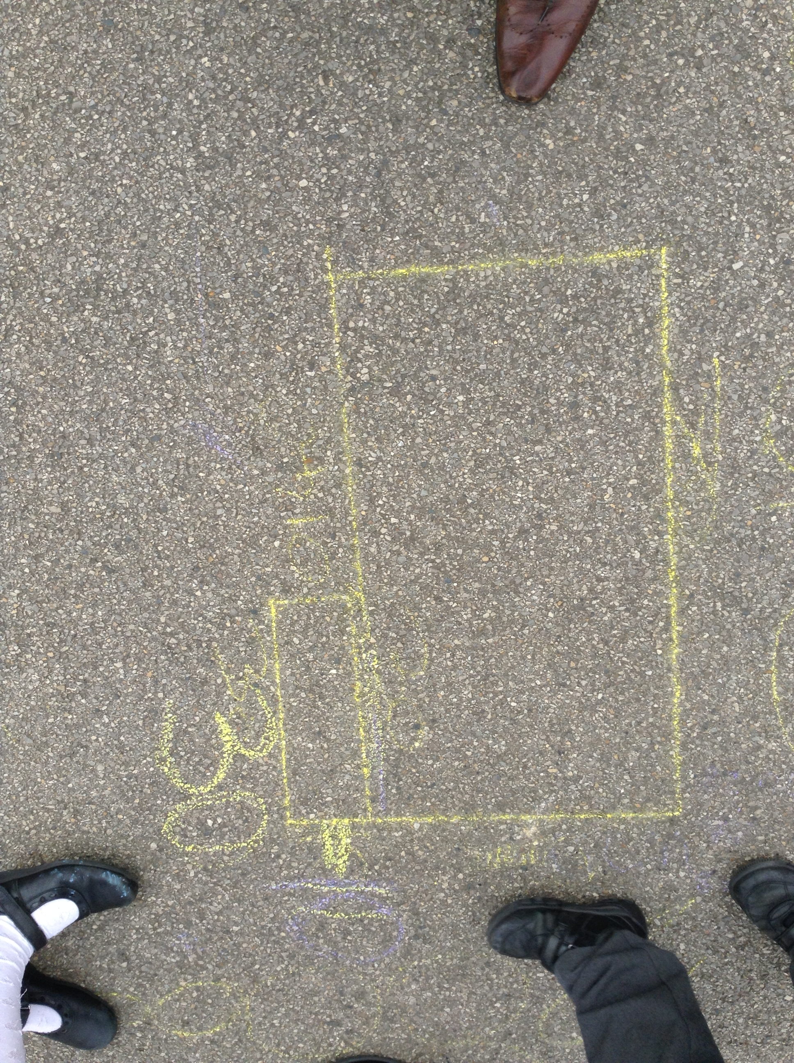
Video from the lesson on the website.

