

Maths Paths in Europe - Lesson Plan

Category: Maths in the Shops
Year Group: Year 4 ( 8 – 9 + years)

Learning Objective:

Use all four operations to calculate cost and solve multi-step problems.

Success Criteria:

- Children apply knowledge from previous lessons to solve problems
- Use all four operations
- Chose appropriate operation to calculate
- Work in context of money

Lesson Description (including context) :

Prior to this lesson, the children had been learning about mountainous areas and Tourism (economy) which made for good cross curricular links.
The children use ‘real life’ examples of holiday destinations and brochures to cost out the price of a holiday.
They must use all four operations working within various budgets.

Resources:

Smart board
Holiday brochures
Adapted brochures (SEN)
Calculators
Individual white boards and pens.
A3 paper, scissors and glue (optional)

Differentiation:
The children are working within ability groups.
Questions are differentiated through challenge. E.g. Less able are asked to calculate cost of 3 people at a set price.
More able will include additional items such as ski-passes, tours and room upgrades.
Challege – Children are working within a budget and may have to look at several resorts to find a ‘package’ that suits their brief.

Introduction:
Begin by explaining to the children that they will be taking on the role of a travel agent. Ensure all children understand what the role entails (helping families to find the right holiday) What factors might influence the right kind of holiday. Take feedback and note down (destination, climate, cost, food, activites).
Focus on the cost – everything else might be perfect but if we cannot afford to go then it can not happen.

On the visualiser, show a page from a travel brochure – highlight the prices at the bottom of each page – ask some simple questions.
How much is a room in January? March? Why is it most expensive in July/August?

Explain that the cost is calculated per person so if 2 people were wanting to stay we would pay double the price.

Highlight other costs – particularly for ski resorts (ski hire, ski passes etc).

Show an example of a how a basic calculation would be done working on a per person costing.
Show how I have used addition and multiplication – it is a multi-step problem.

Main Lesson

Give the children a selection of brochures (check that they have a clear cost grid on each page).
SEN children have a ‘mock’ brochure with costs which are easier to calculate.

Give each group/pair a scenario or brief. Eg. A family of 4 for 2 weeks at ### resort.
Additional challenge will be given when a budget is used. E.g. Find a suitable holiday for a family of 4 for a week in July within a budget of £2500.
Children can be further questioned to find out the change or add additional extras as mentioned above.

Children could use A3 paper and make a collage of their research ready to present back to a family showing the options available to them.
Plenary

Show a costing for a family.
Show a special offer on the board that if 2 children travel, the price will be reduced by 1/5.
How will this impact on the costs? How could we work this out? What will the new total be?

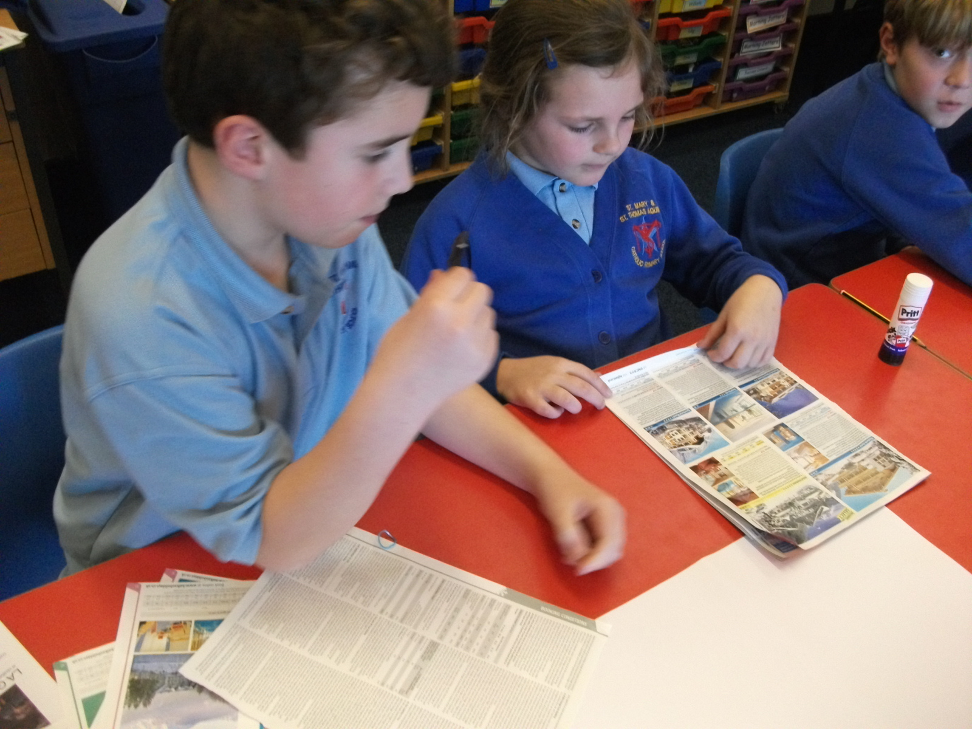
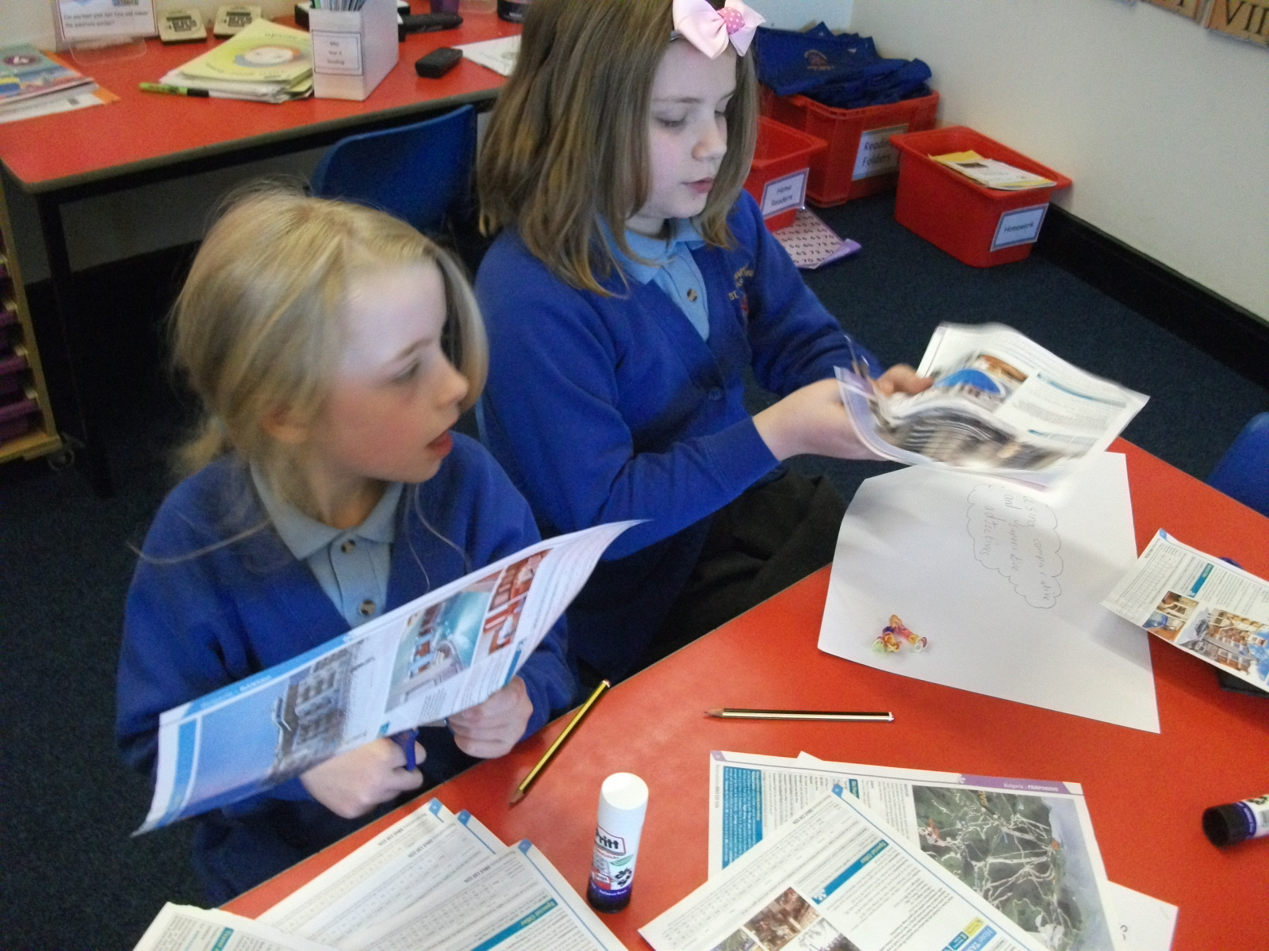
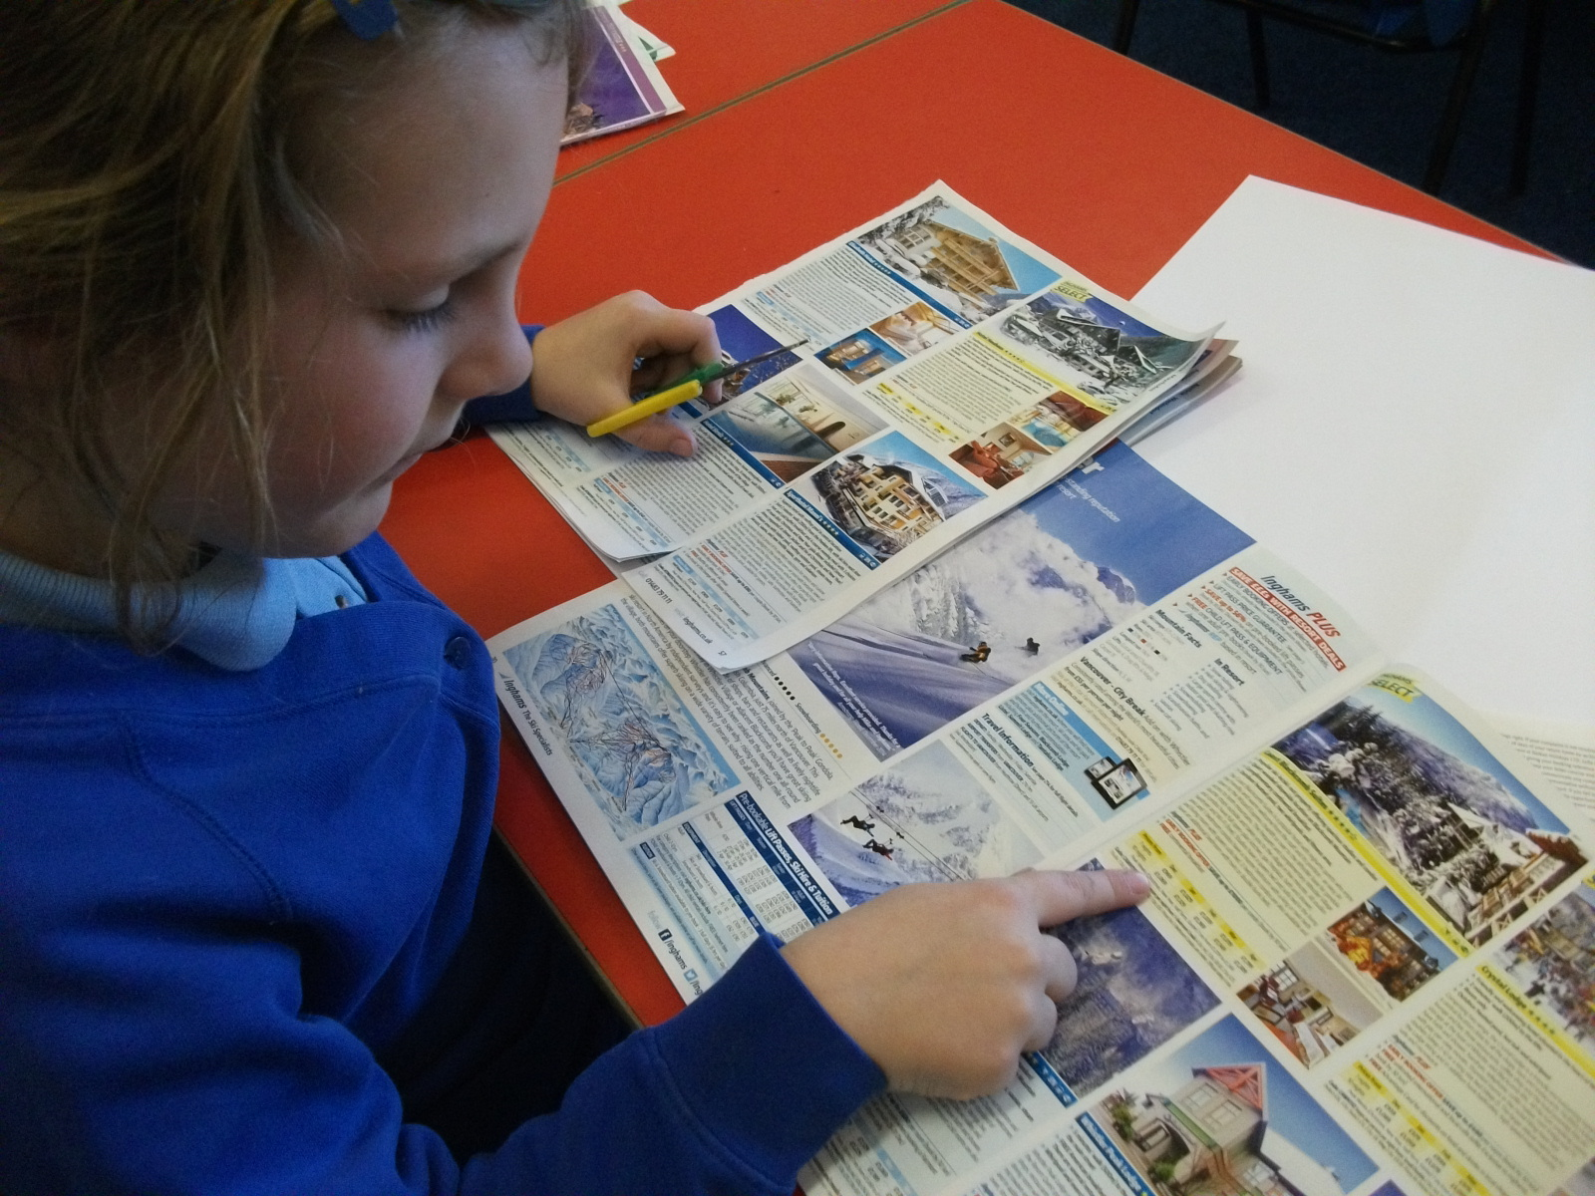
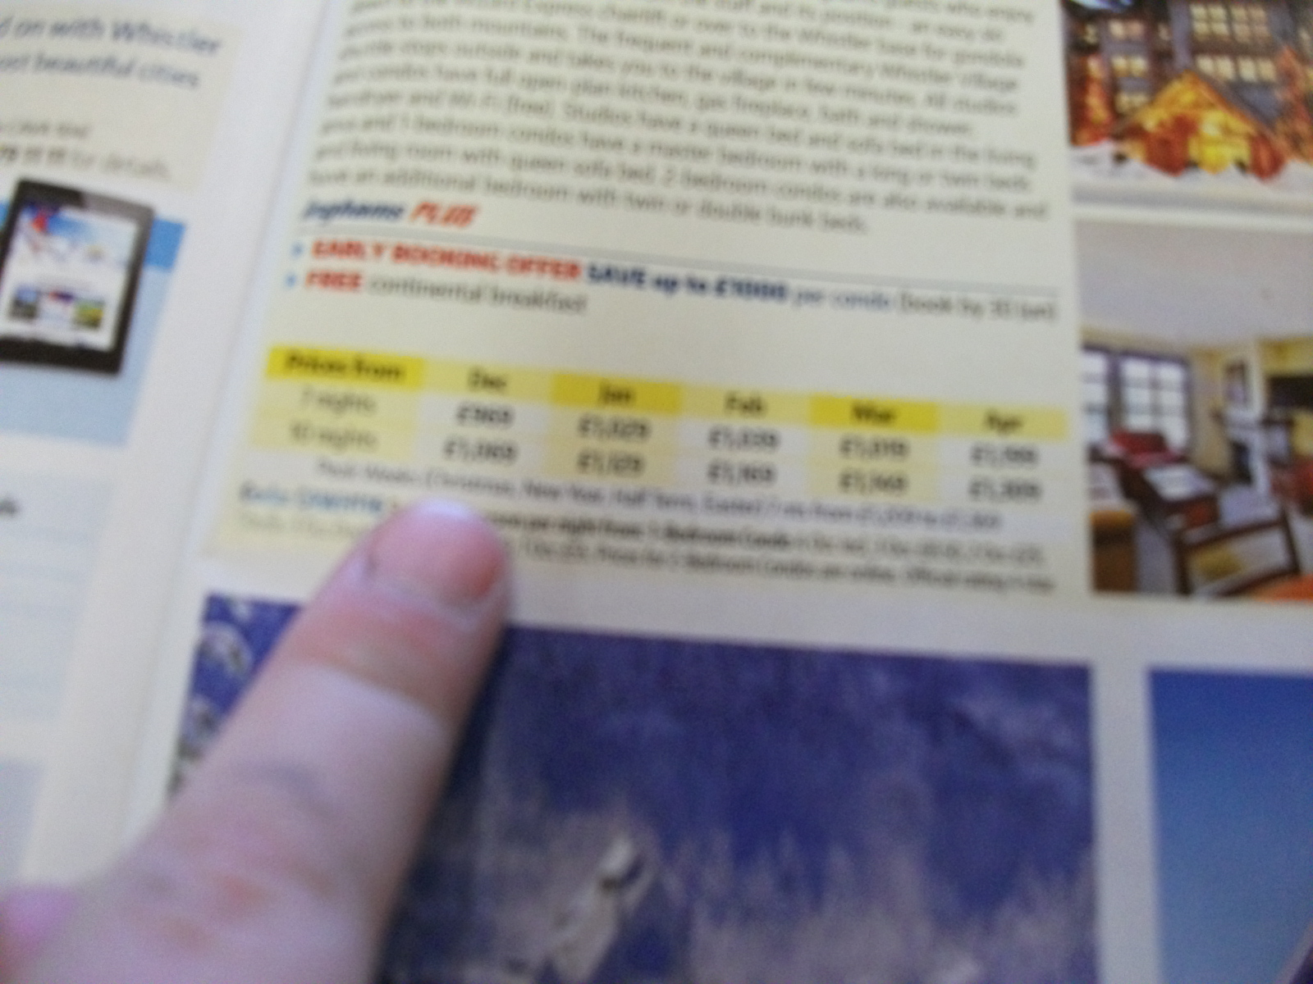
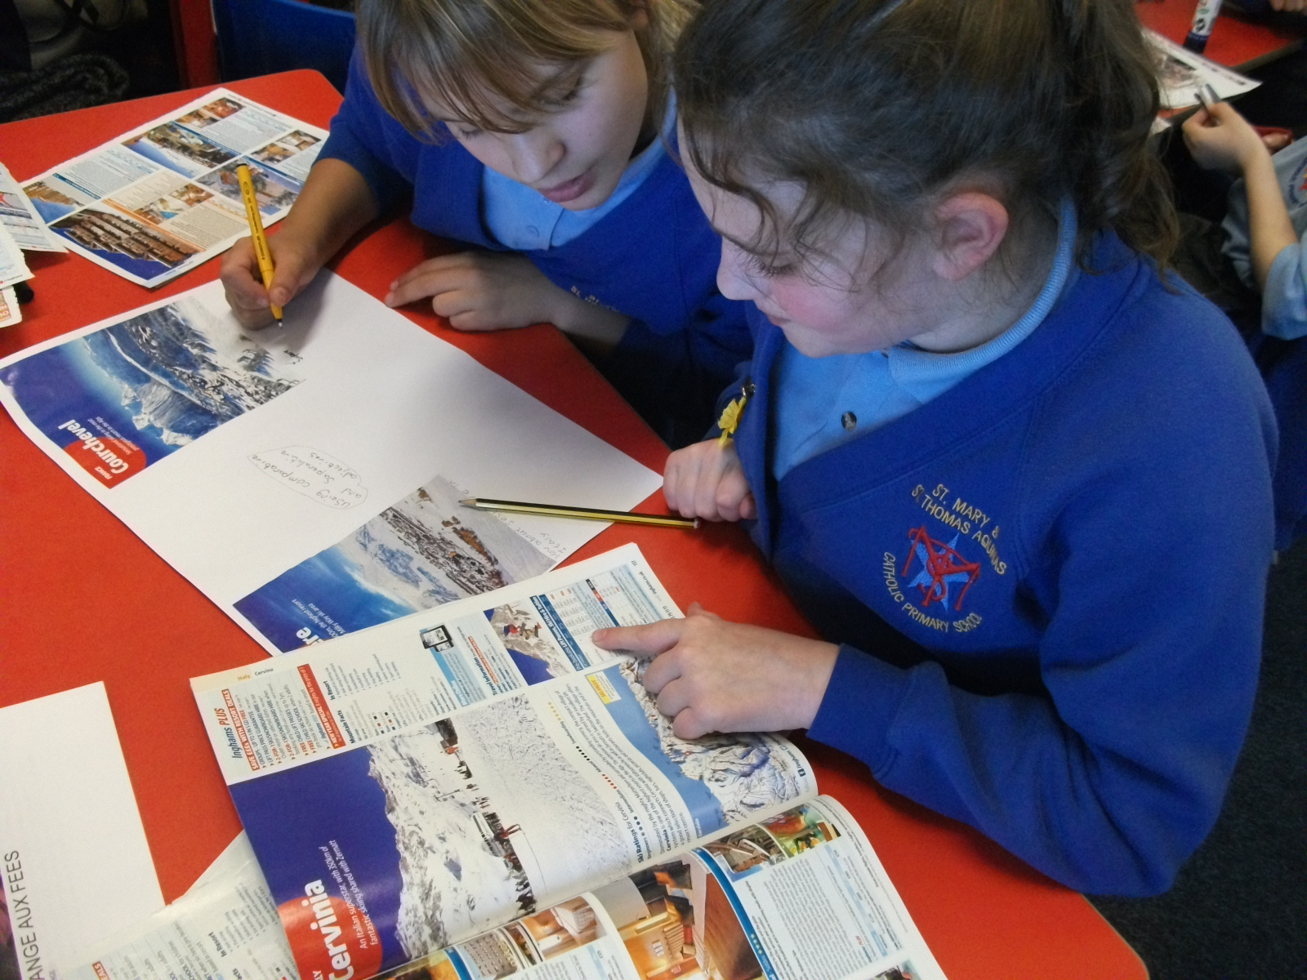
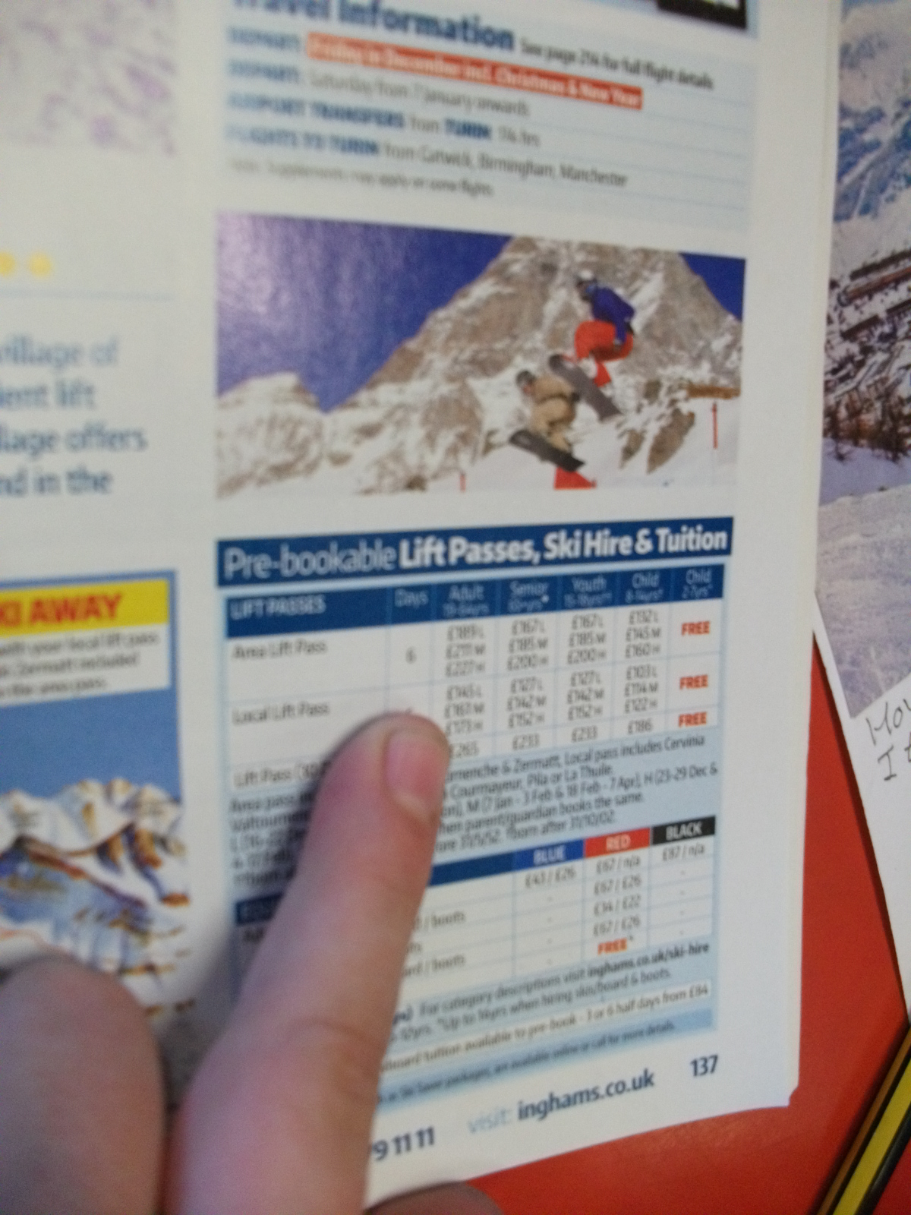
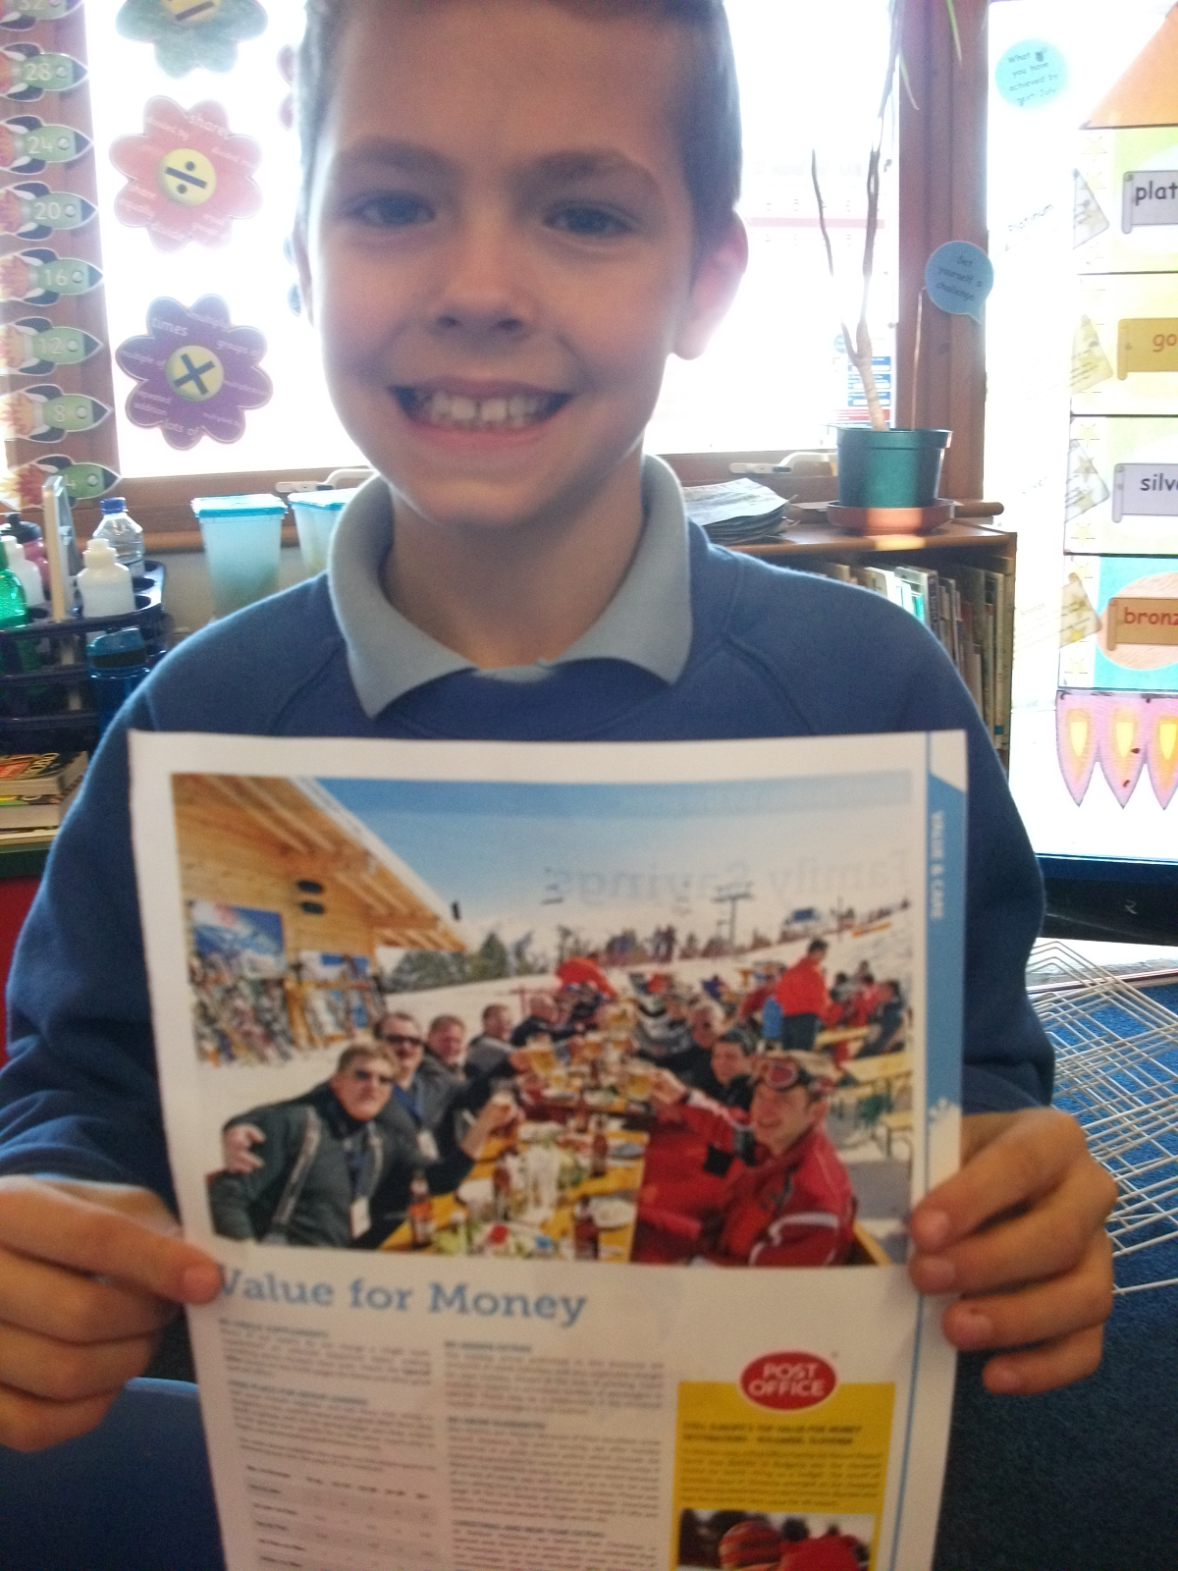
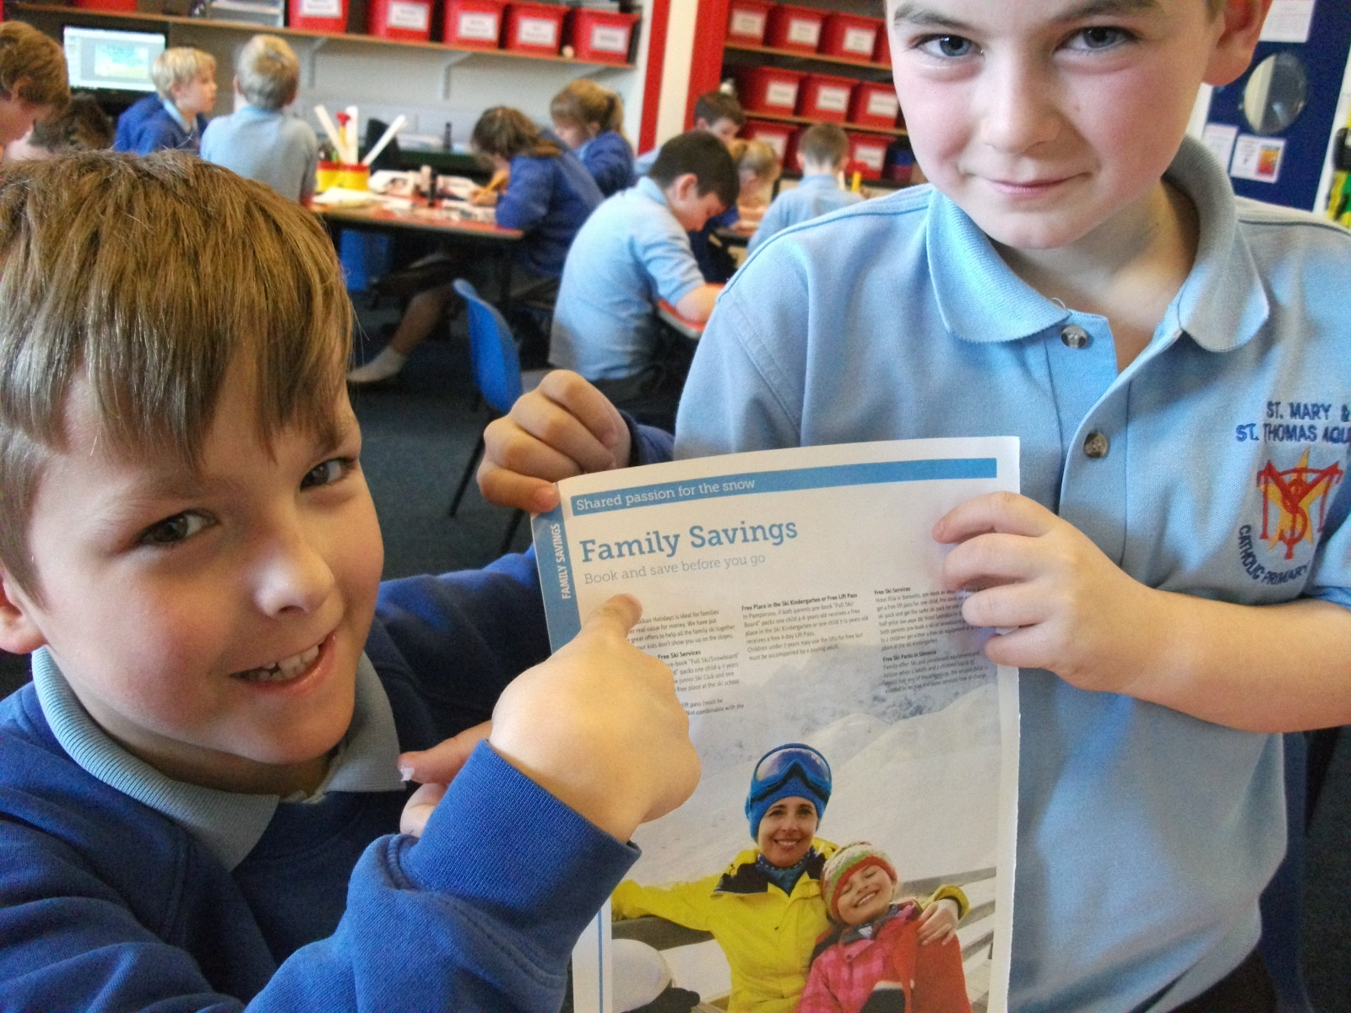
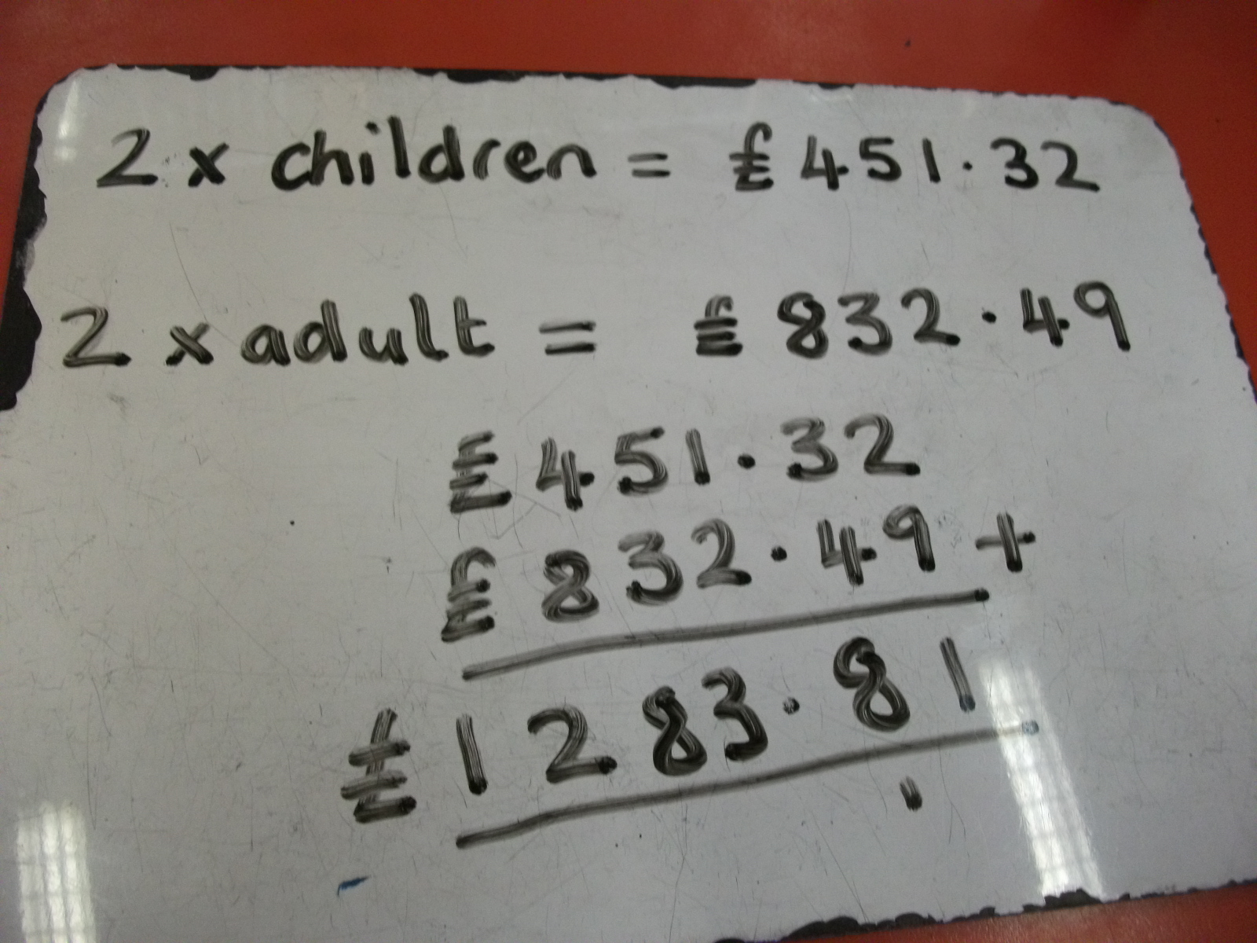
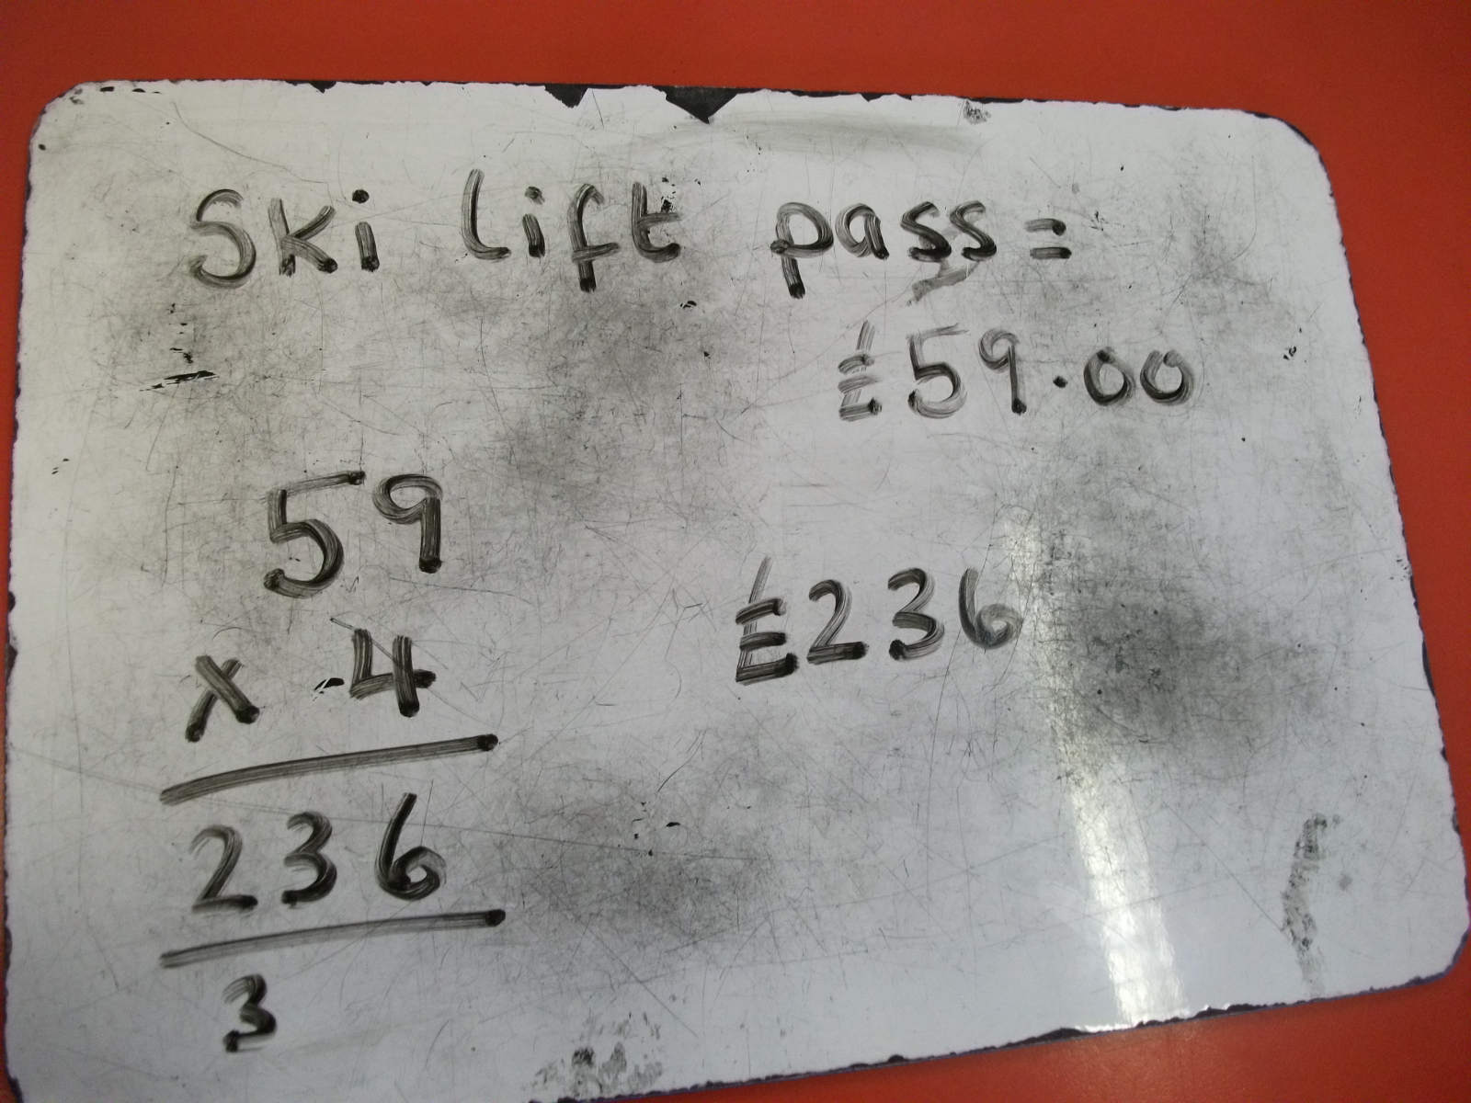
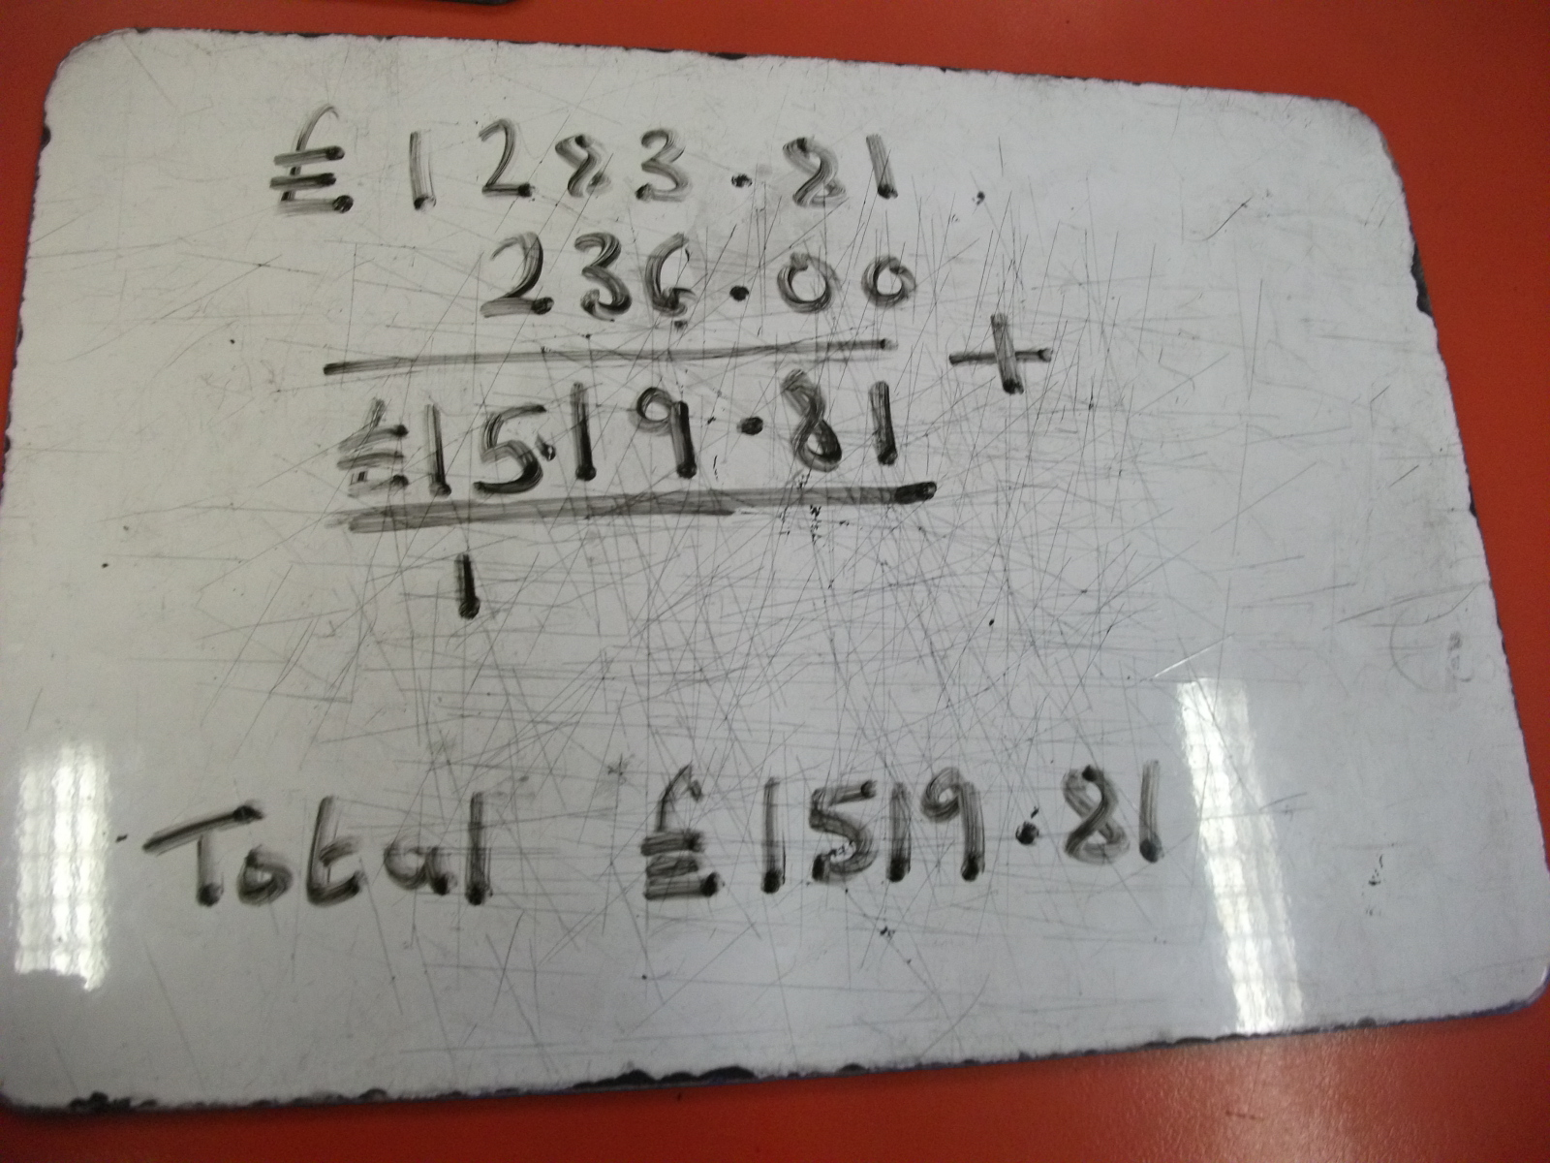
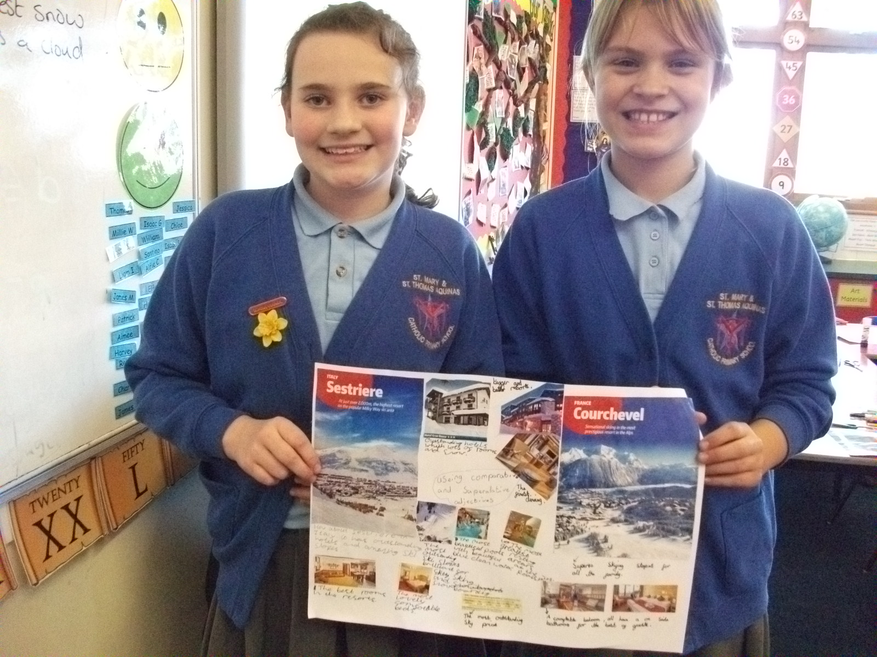
Photographs



