

Maths Paths in Europe - Lesson Plan

Category: Maths in the Garden
Year Group: Year 4 (8 – 9 years)

Learning Objective:

Accuratey measure and calculate length

Success Criteria:

- Children apply knowledge from previous lessons to solve problems
- Use of correct maths vocabulary (measure, circumference, average)
- Choose appropriate equipment to solve a problem
- Read and record units of measurement accurately
- Calculate using units of measurement

Lesson Description (including context) :

The children have previously measured the length of straight objects accurately, chosing appropriate equipment.
The lesson begins in the classroom with a quick recap of the vocabulary used in measurement. We will introduce the word circumference in relation to shape.
The children are then asked how they could find the circumference of a 2D circle. Allow children time to estiamte using string and then measure the length of the string to compare.
The children will then be asked to choose equipment to measure the circumference of the trees in the wildlife garden and compare circumference

Resources:

Smart board (pictures of trees)
Measuring equipment
string

Differentiation:
The children are working in mixed ability groups to allow for peer support.
Additional adult asked to support SEN children. Support chn and facilitate discussion during classroom work and model on whiteboard when necessary. Work with group outside.
Questioning and level of challenge throughout the lesson.
See Challenge activity

Introduction:
Show a shape on whiteboard – ask chn to generate a success criteria for measuring the outside of this shape. (You will refer back to this). Introduce the word circumference.

Show how this is the whole length around the outside of the circle – compare to the perimeter.
Ensure all children are clear on new vocabulary.

Main Lesson

On whiteboard, show a circle with the circumference given.
Ask children – How could I measure the circumference of this shape? Use talk partners to facilitate discussion.
Depending on response, further prompts may be needed. Model how the shape can be measured using a piece of string. First estimate and place string around the shape. Mark the point around the circle and then measure the length of string accurately.

Now show some 3D cylindrical shapes. How could I measure these?
Explain that we are going to be doing some ‘big maths’ outside using our measuring skills.
When outside explain to chn that there is a selection of equipment to use – they must decide what equipment is most appropriate for each challenge.

Children are to accurately measure the circumference of several trees, completing the sheet as they go. White boards may be used to make recording easier.

When children have measured 4-5 trees they should compare the measurements and order from largest –smallest /smallest to largest.

Teacher to question the children – find me the smallest tree/largest tree – Show me the trees which are between 30cm and 50cm.

Once data is recorded, set children on a carousel of different tasks.

1 – Work out the average circumference (mean)
2- Work out the average circumference (median)
3 – Work out the difference in sizes.
4 – Work out range of data.

Extension – Measure distance between the trees and plot an ariel map of the ground (older children could draw to scale)
Plenary
Bring back to classroom or if there are many trees in the area, use some examples outside.
Pose the question – does the age of a tree affect its circumference? Alow time to discuss and ask how children could inestigate this question further.
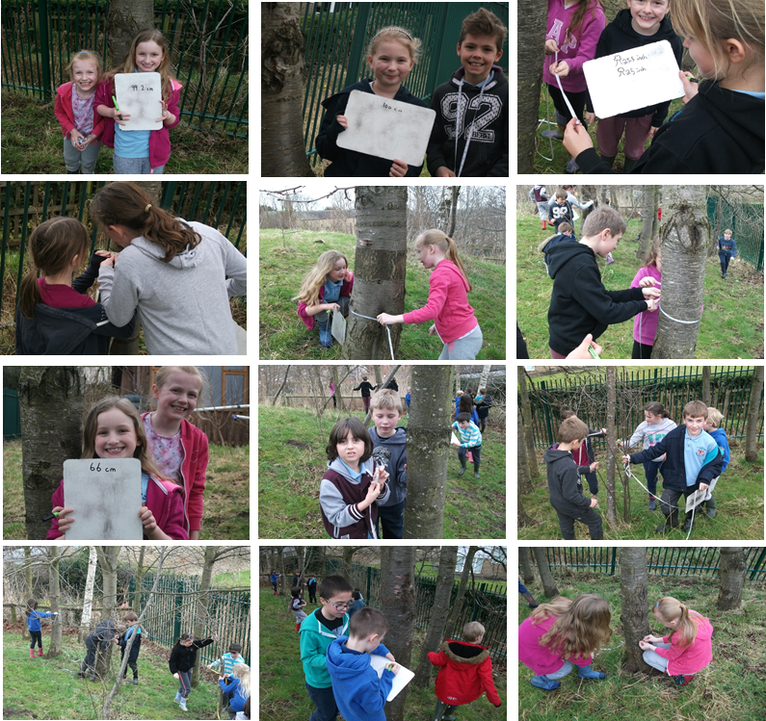
Photographs

