
Ministry of Education and Scientific Research

County School Insectorate Sălaj
KINDERGARTEN “ION CREANGĂ” ZALĂU




Activity project
INDEX 2/2.1.5/2015-2016
Nr. 575/06.11.2015
Vizat,
Director, prof. drd. Negru Emilia

Group: combined
Teachers: Major Katalin; Molnar Rozalia
Theme: Santa’s surprise
Activity: math
Type of activity: consolidation of knowledge
The way of realisation/ embodiment: didactic game (teaching game)
The goal of the activity: consolidation of math knowledge (notions of groups, notions of numbering)
Operational objectives: children
- to form sets of Christmas tree ornaments
- to compare groups by amount of ornaments
- to set the correct digit and place it to the correct group
- to handle with precision, skill and speed the materials
Teaching task: to group the Christmas tree ornaments and to set the correct digit to the correct group
Rules of the game: The children must execute the tasks gived by the teachers, to verbalize the actions that they are doing. They must cooperate to realize the tasks and to describe the way they proceeded to realize those tasks.
Methodes and procedures: exercise, questioning, explanation, demonstration, conversation, game, contest, surprise, song
Teaching materials: a Christmas tree, Christmas tree ornaments, digits, magnetic blackboard, working sheets, badges, paper Christmas tree, counters, working sheet, writing instruments, boxes with surprises

The form of realization: frontal, in small groups, individual
Bibliography: Curriculum for preschool, 2008
Magazine of preschool education no.3-4/2015


Duration: 35-40 minutes






Plan lesson

Didactic event | Scientific content | Teaching strategies | Evaluation
Organizatoric moment | Ensuring the proper conditions for the activity (ventilation of the room, preparation of the materials)
Capturing attention | The teachers enter into the room with two boxes (one big and one small). The boxes are placed near the Christmas tree. Together with the children they try to discover the content of the box. One children will open the box, and after that all the children will sing the „Jingle bells” song. The content of the small box will be discovered at the end of the activity. | Surprise  Conversation Song
Announcing the theme | The teacher propose to the children a game with the surprises sent by Santa. The teachers will also briefly present to the children the activity objectives. | Explanation
The presentation of the  content  and directing learning | The children will be introduced to the rules of the game. The teacher will demonstrate the way the game should be played, and also the criteria which will be take in account in apreciating the answers. The trial game is executed once, giving additional indications.  Variant I:  The children will be asked to form groups with Christmas tree ornaments by their form (globe, bell, candle, angel, star).  Variant II:  The teacher will ask to the children to decorate the Christmas tree respecting certain criteria: on a branch they have to place big globes, on another branch little bells/ red candles/ white angels/ yellow bells/ little angels/ big stars.  Variant III:  The teacher will ask the children to count how many Christmas ornaments they placed on each tree branch and to place the correct digit to the correct group. | Explanation  Demonstration Conversation  Questioning Exercise  Game | Verbal feedback
Ensuring retention and transfer | Variant IV:  Contest between two teams. Based on the received badges (bell or star) the children will be distributed/ divided into two teams. Each team will receive a paper Christmas tree which will be decorated based on the criteria drawed on a received chart.  The winning team will be the one which will finish first the Christmas tree decoration. | Questioning Exercise  Contest
Evaluating the performance | Individual work – working sheets.
The closure of the activity | General and individual appreciation are being made, and after that the children will open the little box with surprises. Each child will receive a gypsum bell and all the children will sing „O, Christmas tree”.

Attachment for variant IV of the game:


2 
3 

1
3 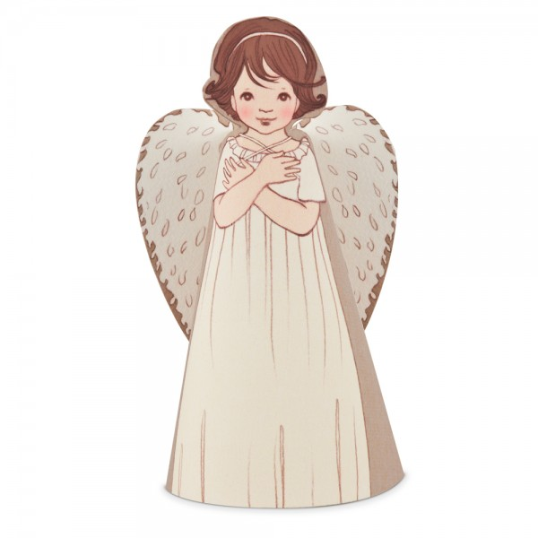
5 

4 
2 
3 

Work sheet
- Form groups and place the correct digit to the correct group!
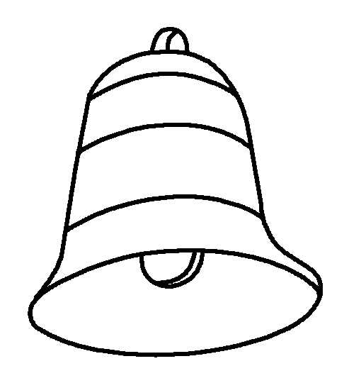
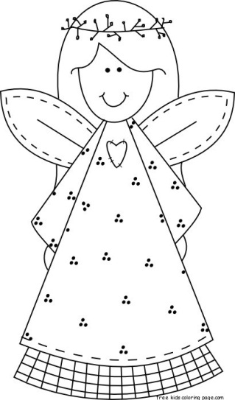





3 2 4 1 5

