Polish Christmas Recipes

Beet Soup
"Barszcz"
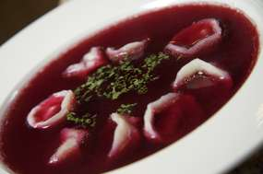

3 or 4 whole beets
2 cans of vegetable, mushroom, or beef broth
2 cups of water
4 cups of tomato or vegetable juice
juice of 1/2 lemon
1/2 teaspoon sugar
1/2 teaspoon pepper
1 teaspoon salt
Strain the beets and set aside. Combine beet juice, broth, water and tomato or vegetable juice in an enameled or stainless steel soup pot. Bring to a gentle boil -- do not let the soup boil for more than a minute or it will lose its clear red colour. Grate the beets from one or two cans into the soup. Add lemon juice and seasonings to taste. Reheat before serving, making sure not to bring to a boil. Place 5 or 6 uszka dumplings in each bowl before serving and pour barszcz over them

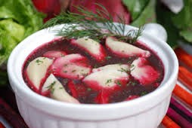

Mushroom Dumplings
"Uszka"

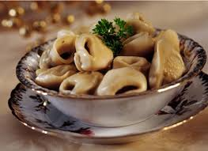
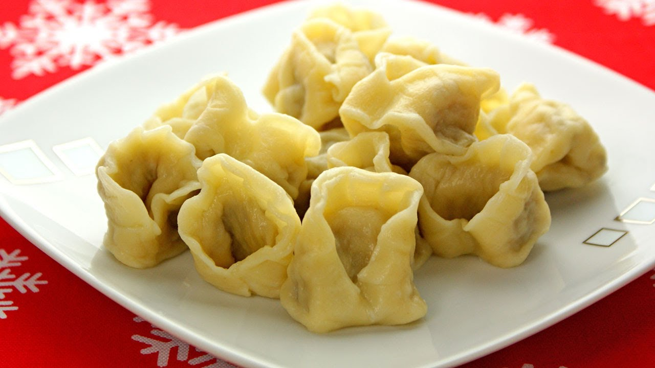

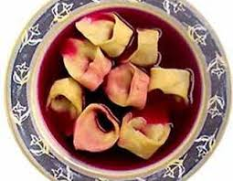

For the stuffing:
16 ounces fresh mushrooms, finely chopped
1 butter
1 medium-sized onion, finely chopped
white of one hard-boiled egg, finely chopped
2 tablespoons breadcrumbs
1 tablespoon parsley, chopped
Salt and pepper to taste
Sauté the mushrooms and onions in the butter for 10-15 minutes. Add bread crumbs, finely chopped egg white, and parsley. Mix well and add salt and pepper to taste.
For the dough:
1 egg yolk
2 cups of white flour, sifted
1/2 cup lukewarm water
Mix the flour with the egg yolk, adding water slowly and working it into the dough until a soft mass is formed. Keep kneading until the dough no longer sticks to your fingers. Roll dough into a ball and cover with flour. Place in a bowl covered with plastic and refrigerate for an hour.
Roll out a third of the dough into a thin layer on a floured surface and cut into 1 1/2 inch squares. Place a spoonful of the mushroom filling in the center of the square of dough, fold in half to form a triangle, and press the edges tightly to close. Then bring two corners of the triangle together and press tightly. Place dumplings on a floured dishcloth and cover with another cloth until ready to cook. Repeat with rest of dough. Cook dumplings in batches in boiling, salted water for 5 minutes, until they float to the top. Take out with slotted spoon and toss in meted butter. Serve immediately with barszcz or refrigerate and reheat gently before serving.

Dried Fruit Compote
"Kompot z Owoców Suszonych"

1 1/2 pounds mixed dried fruit
6 cups of water
1 lemon
6 whole cloves, 1 cinnamon stick
1 cup of sugar
Rinse and soak fruit in 4 cups of water overnight in a ceramic or glass bowl. Transfer fruit and the water into to a stainless steel or enameled pot, add 2 more cups water, sugar, cloves, and cinnamon. Peel the lemon, leaving the peel in one piece, if possible, and add the peel to the pot. Then cut the peeled lemon in half and squeeze the juice into the pot. Cook for 30 minutes, adding more water, lemon juice, or water to taste. Refrigerate for a few hours. Serve cold in glass bowls, along with Christmas cookies, for dessert.

Christmas Wheat Berry Pudding
"Kutia"

Ingredients:
1 cup whole wheat berries
2 cups hot water
1/2 cup poppy seeds
1/2 cup slivered almonds
1/2 cup white raisins
1 shot vodka, rum, or brandy (optional)
1/2 cup honey
Extra honey and heavy cream, for serving
Soak wheat berries in two cups of hot water for two hours or overnight. Drain wheat berries and place in an enameled pot. Cover with cold water, bring to a boil, reduce heat, and cook over low heat for two hours, or until all liquid is absorbed. Let cool. Cover poppy seeds with a cup of boiling water for 30 minutes. Drain through a fine sieve and place in a glass bowl to dry. Grind poppy seeds in a coffee grinder or food processor, until the seeds start to show their white interiors. Add ground poppy seeds to the wheat berries and then add almonds, raisins, and honey. Mix well. Add more honey if needed. Refrigerate.
Serve kutia cold in small glass bowls with extra honey on the side. Add 2-3 tablespoons of heavy cream (or half and half) to each serving. Wheat ferments easily, so be sure to refrigerate any leftovers. The kutia will hold well for up to a week, if it is refrigerated.
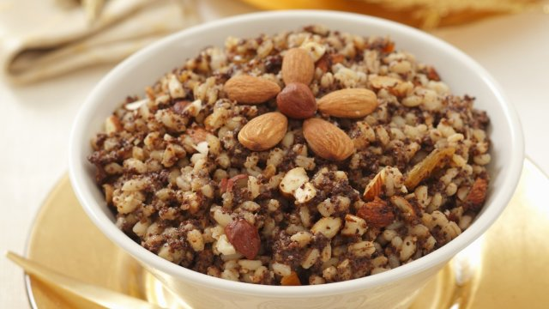

Sauerkraut with Mushrooms
"Kapusta z Grzybami"

2 ounces dried mushrooms
16 ounces fresh mushrooms (portabella mushrooms preferred)
1 large onion
4 tablespoons butter
1 1/2 pounds sauerkraut, rinsed in cold water, and drained
1/3 cup water
2 tablespoons flour
salt and pepper
Soak the dried mushrooms in 2 cups of hot water for 2 hours drain, and squeeze dry in a cheesecloth. Chop finely. Wash and coarsely chop the fresh mushrooms and onion and sauté in the butter in a skillet for 5-7 minutes. Add sauerkraut to mushrooms; cook and stir for another 10 minutes.
Blend 1/3 cup water into flour, beating gently to remove lumps. Add slowly to sauerkraut and simmer for 15 minutes. Season to taste with salt and pepper.

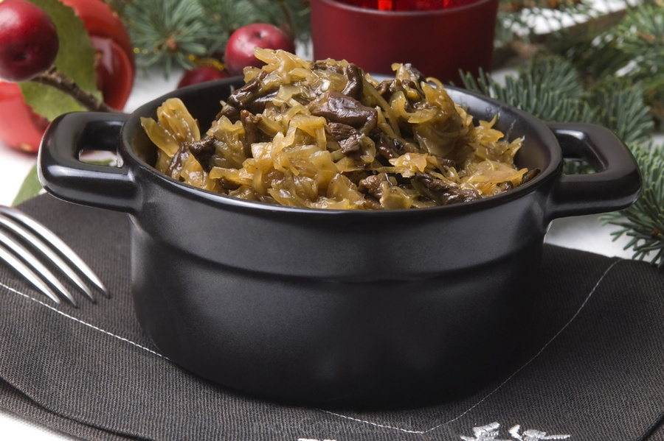
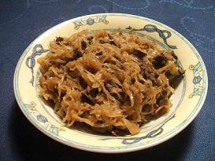
Mushroom Cabbage Rolls
"Gołąbki z Grzybami"

1 large cabbage (with big leaves)
1 cup uncooked long grain rice
2 large onions, finely chopped
16 ounces fresh mushrooms
2 ounces dried mushrooms (optional)
1 stick of butter
6 cups of tomato juice or mushroom stock
salt and pepper to taste
Take out the hard core of the cabbage with a sharp knife. Place the cabbage in a large pot of salted, lightly boiling water for approximately 10 minutes. When the outside leaves are tender, peel them off gently with a fork. You may have to peel the first layers first and then return the cabbage to cook and continue peeling the leaves until all are done. Cook the rice according to package instructions until just tender and set aside.
If using dried mushrooms, soak them in hot water for two hours. Drain, squeeze out excess water, and chop finely. Wash and chop the fresh mushrooms. Sauté the onions in half of the butter until softened and then add mushrooms. Cook for another 10 minutes, adding more butter as needed. Add mushrooms and onions to the cooked rice, mix and season well. Place two tablespoons of the mushroom and rice mixture in each cabbage leaf and wrap it carefully, rolling the leaf and folding the ends under tightly, like a parcel.
Heat the oven to 350 degrees. Grease a deep roasting pan or large casserole and fill it with the cabbage rolls, packing them tightly together. Pour enough tomato juice or mushroom stock to cover the rolls. Cover tightly with foil and bake in oven for 40 minutes. Uncover and bake for another 10-15 minutes to brown the rolls lightly. Serve with sour cream or mushroom sauce.

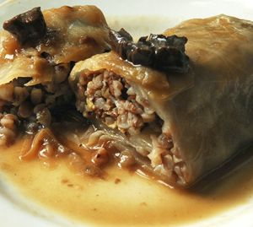
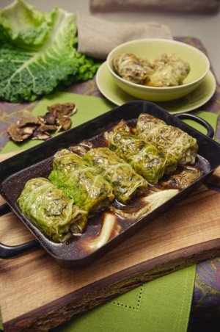

Polish Dumplings
"Pierogi"
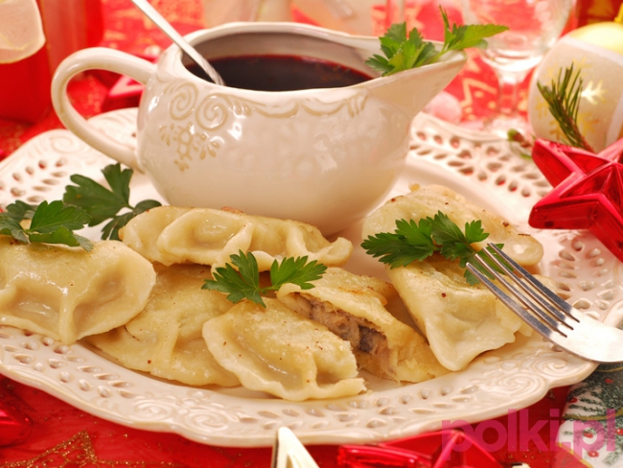

Pierogi Dough
2 cups all purpose flour
2 eggs
2 tablespoons sour cream
1/2 teaspoon salt
1/2 cup lukewarm water
Mound flour on a large cutting board and make a well in the center. Drop eggs, sour cream, and salt into well. Add water a few drops at a time and work it into the flour with a knife, moving slowly from the center to the outside of the flour mound. While mixing the liquid into the flour with one hand, keep the flour mounded with other hand. Try not to let any liquid break through the walls of the mound.
When all the water and egg is mixed into the flour, knead until the dough is firm and well mixed and no longer sticks to yours hands (about 10-15 minutes). Add flour if it seems too sticky; a few drops of water if it seems too dry. Then cover the dough with a bowl or clean dishtowel and let rest for 30 minutes.
Divide the dough into halves. On a well-floured surface, using half of the dough at a time, roll it out as thinly as possible. Cut out 3-inch rounds with a biscuit cutter or a drinking glass. Then place a tablespoon of filling in the middle of each round of dough, fold over carefully and press edges together. Be sure to press firmly as filling will spill out during cooking if the dough rounds are not well sealed.
Pierogi can be frozen at this point. Layer carefully in freezer container, be sure to separate layers with wax paper. If you are going to eat right away, drop 12-20 pierogi into a large pot of boiling, lightly salted water. Cook gently 3 to 5 minutes, or until pierogi float. Lift out of water with perforated spoon.
Toss in butter and place in heatproof serving dish. Pierogi can be reheated in the microwave or in the oven, just before serving. They can also be reheated by frying in butter. Serve pierogi with sour cream and chopped chives.
Sauerkraut and Mushroom Filling
2 cups sauerkraut
2 tablespoons butter
1/2 cup chopped onion
4 ounces mushrooms
1/4 teaspoon pepper
1 hardboiled egg, finely chopped
1 tablespoon breadcrumbs
2 tablespoons sour cream
Rinse sauerkraut in cold water and drain well. Sauté for 10 minutes in medium saucepan until dry. Set aside. In frying pan, sauté onion and mushrooms in the remaining butter. Add sauerkraut and pepper. Fry until sauerkraut is golden. Add chopped egg, breadcrumbs, and sour cream. Mix. Cool thoroughly before stuffing pierogi.
Potato and Cheese Filling
4 Russet potatoes
8 ounces farmer's cheese or dry cottage cheese
1 onion, finely chopped
2 tablespoons butter
Salt and pepper to taste
Peel and boil the potatoes until tender. Mash until smooth and let cool. Sauté chopped onion in the butter. Let cool. When mashed potatoes are cool, add onions and cheese. Mix well. Add salt and pepper to taste before filling pierogi. Serve with sour cream.
Cheese Filling
8 ounces dry cottage cheese, farmer's cheese, or ricotta.
1 egg
2 tablespoons sugar (to taste)
1/2 teaspoon vanilla extract
1/2 cup raisins (optional)
Mix well before stuffing pierogi. If using raisins, soak them in warm water for one hour and drain and dry well before adding to cheese mixture.

